Language Arts and Literature 2011-2012
Miss Wood
Dear parents/guardians,
This year, your students will engage in Literature Circles. In these circles, your students will read a book in order to dissect and discuss their novel with students that may or may not be reading the same novel. This will expose each student to a variety of literatures with similar themes, settings and characters. Your student may or may not read the books below. They certainly will not read all of these books in class. Please indicate whether you consent to your child reading or discussing a piece of literature by checking circling “yes” or “no” and provide your initials. Please also sign the bottom of the backside of this form. I have included a short synopsis and possible negative content (if any) within each book. However, I will gladly discuss any of these novels with you should any questions or concerns arise.
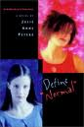_________________________________________________________________________________________________
Define Normal by Julie Anne Peters

"Antonia Dillon is a good student in middle school, but to make her college application look better, and to help some of her peers, she decides to participate in a peer counseling program. Dr. Dileo, the guidance counselor chooses the partners, and for some strange reason, he puts her with Jasmine Luther, otherwise known as Jazz. Jazz wears black eyeliner, lip gloss, nail polish, and clothes. When Antonia sees Jazz, she is ready to quit, but since she can't they go ahead and have their first session. Then she has to go home and do homework, but she can't because she has to take care of her little brothers, Chukie and Michael, because her mom is bipolar.

Parent initials:______________ YES NO
_________________________________________________________________________________________________
The Outsiders by S.E. Hinton
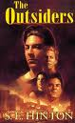
According to Ponyboy, there are two kinds of people in the world: greasers and socs. A soc (short for "social") has money, can get away with just about anything, and has an attitude longer than a limousine. A greaser, on the other hand, always lives on the outside and needs to watch his back. Ponyboy is a greaser, and he's always been proud of it, even willing to rumble against a gang of socs for the sake of his fellow greasers--until one terrible night when his friend Johnny kills a soc. The murder gets under Ponyboy's skin, causing his world to crumble and teaching him that pain feels the same whether a soc or a greaser.

Parent initials:______________ YES NO
________________________________________________________________________________________________
Al Capone Does My Shirts by Gennifer Choldenko
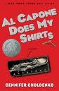
Moose Flanagan and his family have just moved to Alcatraz Island so that his father can take a job as a prison guard and his sister Natalie can go to a special school in San Francisco. Moose must take care of Natalie after school while his mother teaches music lessons, and he must find a way to deal with Natalie’s screaming fits and constant needs. Complicating Moose’s life even more is Piper, the daughter of the prison warden. Piper lures Moose into her scheme to make money by collecting laundry from their classmates with the promise that Al Capone is among the convicts assigned to laundry duty on Alcatraz.

Parent initials:______________ YES NO
_________________________________________________________________________________________________

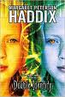Double Identity by Margaret Peterson Haddix

As Bethany approaches her 13th birthday, her parents begin acting more oddly than usual: Her mother cries constantly, and her father barely lets Bethany out of his sight. Then one morning he hustles the entire family into the car, drives across several state lines--and leaves Bethany with an aunt she never knew existed.
Parent initials:______________ YES NO
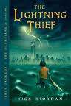_________________________________________________________________________________________________
The Lightning Thief by Rick Riordan
When troubled student Percy Jackson vaporizes his math teacher on a class field trip, he begins to suspect that his life is not what it seems. He discovers that his lifelong reading and attention troubles are all signs that he is a half-blood—a child of the Greek gods. After a summer training session with other demigods and Chiron the centaur, he sets off on a cross-country quest to Los Angeles (the entrance to Hades) with his friend Grover the faun and Annabeth, a child of Athena, to recover Zeus’ lost thunderbolt and stop a war between the gods.

Parent initials:______________ YES NO

_________________________________________________________________________________________________
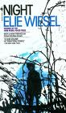Night by Elie Wiesel

Night begins in 1941, when, the narrator of the story, Elie, is twelve years old. Having grown up in a little town called Sighet in Transylvania, Elie is a studious, deeply religious boy with a loving family consisting of his parents and three sisters. However, Elie and his father are soon separated from his mother and sisters. Through his novel, Elie tells a firsthand account of his life experience during The Holocaust.

Parent initials:______________ YES NO
_________________________________________________________________________________________________
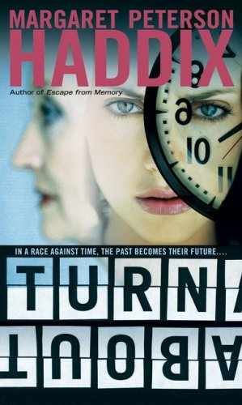Melly Hazelwood and Anny Beth Flix are part of a secret scientific project. It's the year 2085. Melly is 16 and Anny Beth is 18. But, in the year 2000, they were both in their hundreds. Thanks to Project Turnabout, they were given a chance to grow younger, along with fifty other men and women in her nursing home. But, when they signed up, they had no idea of the problems that would face them.

Parent initials:______________ YES NO
_________________________________________________________________________________________________
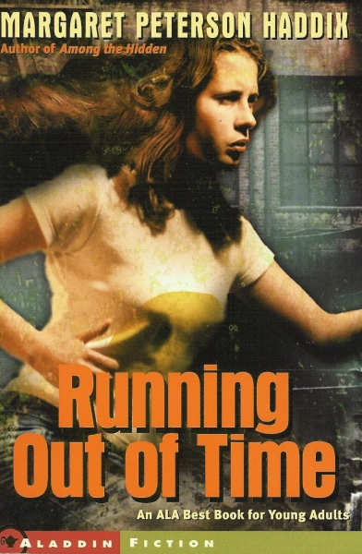Jessie lives with her family in the frontier village of Clifton, Indiana, in 1840 — or so she believes. When diphtheria strikes the village and the children of Clifton start dying, Jessie's mother reveals a shocking secret — it's actually 1996, and they are living in a reconstructed village that serves as a tourist site. In the world outside, medicine exists that can cure the dread disease, and Jessie's mother is sending her on a dangerous mission to bring back help. But beyond the walls of Clifton, Jessie discovers a world even more alien and threatening than she could have imagined, and soon she finds her own life in jeopardy. Can she get help before the children of Clifton, and Jessie herself, run out of time?
Parent initials:______________ YES NO
_________________________________________________________________________________________________

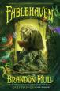Danger lurks everywhere at Fablehaven, where someone has released a plague that transforms beings of light into creatures of darkness. In dire need of help, the Sorensons question where to turn, now that long trusted allies have been revealed as potential foes. Kendra embarks on a special mission that only she can attempt because of her new abilities as fairykind, while Seth stays behind and discovers an incredible new talent of his own. The siblings are put to the test as the threat grows both abroad and home at the Fablehaven preserve, and Brandon Mull spins his richest and most thrilling fantasy tale yet in this third title of the popular fantasy series.

Parent initials:______________ YES NO
_________________________________________________________________________________________________
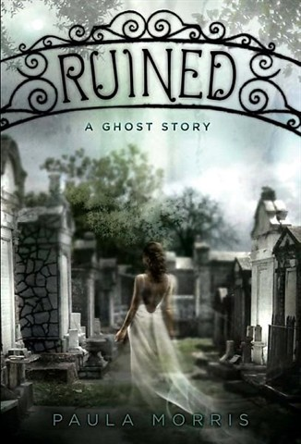
Rebecca couldn't feel more out of place in New Orleans, where she comes to spend the year while her dad is traveling. She's staying in a creepy old house with her aunt. And at the snooty prep school, the filthy-rich girls treat Rebecca like she's invisible. Only gorgeous, unavailable Anton Grey seems to give Rebecca the time of day, but she wonders if he's got a hidden agenda. Then one night, in Lafayette Cemetery, Rebecca makes a friend. Sweet, mysterious Lisette is eager to talk to Rebecca, and to show her the nooks and crannies of the city. There's just one catch: Lisette is a ghost.
Parent initials:______________ YES NO
_________________________________________________________________________________________________

I do allow/not allow my child ___________________________ to read the above indicated novels.

Parent signature: ______________________________________________________

Date:__________________________

